CE318 High level game design - Assignment – Part 1 –
Game design Document
Student ID: 1703620
Game Title:
Lost Girl
Outlook link to project: https://essexuniversity-my.sharepoint.com/:f:/g/personal/ls17545_essex_ac_uk/ElQzb8g8owNJmVJjsJNL2L4BB7O_cr3XxglDppBQc2d9yw?e=lXvaxs
(The active character model is not final and the real is inactive due to it not being complete)

Overview: This game is a low poly style adventure game, based around a character called Abigail where you must look around a map to find collectibles, fight monsters and different environmental effects. There is a range of collectibles, some help the player and others that will give lore to the character. The player may also encounter puzzles that will help them advance further into the game and situations where they may have to look for a required item.
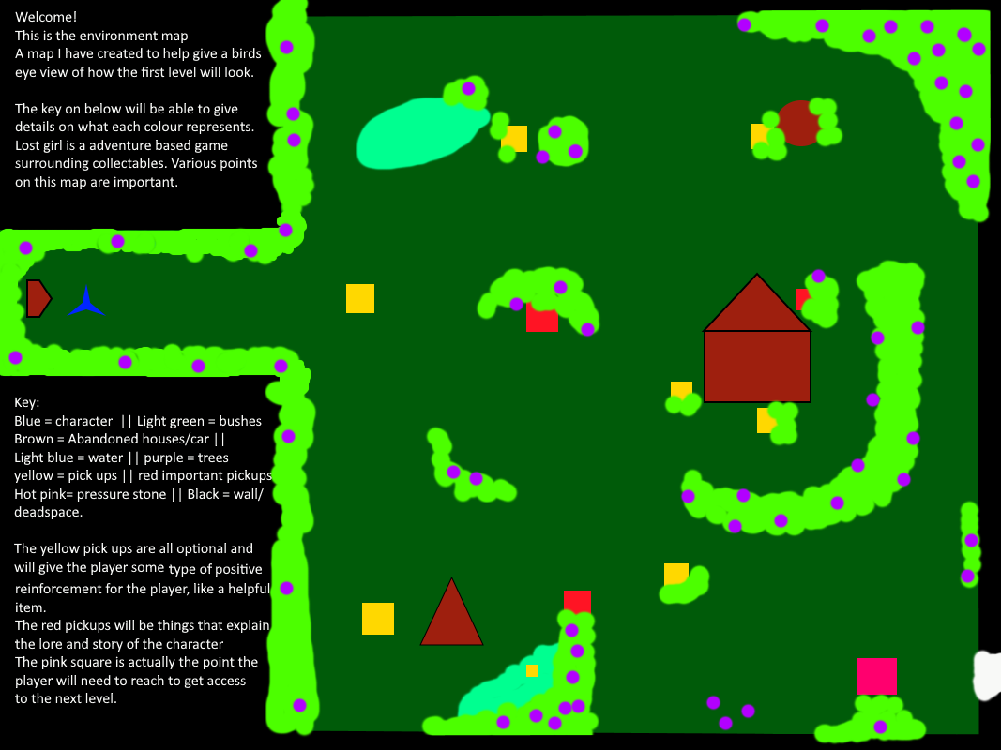

This picture above, I created to show the map outline of how scene 1 will eventually look. Map on outlook folder.

Gameplay:
The main component to this game will be the exploration part. As the game is about collectibles there will be few puzzles and some riddles that will lead the player into the correct direction.
Players will be expected to be able to understand basic movement components, which will be the arrow keys to move, spacebar to jump and E to pick up. Players will also need to be able to think creatively for themselves. As puzzles progressively get more difficult for the player and the various obstacles they may in-counter it may become frustrating to the player. Therefore, another component I've added in is collectable items that the player can inspect which gives them a picture of the game’s universe.

As seen in the map above I have made 3 different types of pick-ups for the player to get:
- Yellow optional items that help the player
- Red are pickups that will give lore insight to the player
- Pink is the trigger point that will tell the player where the exit is when they touch this point.
Yellow pick up will eventually become boxes or chests that the player will need to open and will work with an animation.

Interface:
A health bar and happiness bar on the top left on the corner, an inventory icon, save ion on the bottom left corner of the screen, these icons will have to opened like a menu.
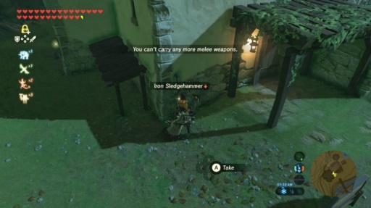
A similar simple look like Zelda’s breath of the wild UI design, so that the screen does not have too many things on it.

Source : https://blog.prototypr.io/user-interface-in-the-legend-of-zelda-breath-of-the-wild-431caf9a3ed0

Objectives; The objective of the game is very simple, from the start you are told to, collect the items, and when you progress deeper into the level it will be come clear you need to escape the current environment, this will mean the player will have to find the key and exit of the level.

Look and feel:
The art style I've taken is a low poly design because of its beginners’ friendly nature and accessibility on unity. As well as it gives an ambience to the game, makes the environment look friendly and opening to the player. The game idea is heavily influenced by Zelda where everything is very beautiful looking however the story is very dark. Therefore, I want to have the level of lighting and music slightly change throughout the level to make the player on edge.

With specific pick-ups within the game, this will then effect how the environment will later on look like, for example lore items will result in the environment getting darker and general quest items will give a short burst of bright light and happy music, both of these would effects would then follow the player while they explore or come towards their next pick-up.

Lastly, the camera style is an off the right shoulder as it’s as if the player is creeping and following then character not exactly playing the game. So that the player can easily see what the character will be walk towards.

Story:
The story of the game begins with Abigail awaken in an odd forest, she’s not sure as to why she is there but decides she must explore the forest. she has little memory as to why she would enter such a dangerous looking forest, but she is determined to regain her memory and return home. Abigail notices her surroundings, she's within a dark deep forest. Maybe she got lost after playing with friends? Now Abigail must get through this forest and back home where she belongs.
Sometimes Abagail can hear a quiet little voice whispering things into her ear however it’s too thin and small to understand but it entrances here and gives her directions to go in. This happened to her often while growing up, Mother would always say it’s the fairies trying to sway her away and to never to listen to them.
The only other thing on Abigail’s mind is her mother that she greatly misses. It almost feels like Abigail hasn't seen her mother in a long time, Abigail still remembers the sound of her mother’s voice and how their home would always be filled with the same of hot cookies.

How she missed home so much, she made her way through the dark forest.

Assets used:
Character Pack: Free Sample, by SuperCyan, https://assetstore.unity.com/packages/3d/characters/humanoids/character-pack-free-sample-79870
Polygon City Pack – Environment and Interior [Free] by wands and circles, https://assetstore.unity.com/packages/3d/polygon-city-pack-environment-and-interior-free-101685
Free Ambient Instrumental music by Pointful,
https://assetstore.unity.com/packages/audio/music/free-ambient-instrumental-music-180790

